**FX LINK - RFP for Central Bank of the Caribbean**

Members: Mahek Shah (Captain), Nabeel Bahrawi (Vice Captain), Pavani Voota

Group 6

Professor Jefferson Bien-Aime

05-19-2023

1. Project Overview

a. Project Name: FXLink - Foreign Exchange Link

b. Authors: Mahek Shah (Captain), Nabeel Bahrawi (Vice Captain), Pavani Voota

c. Document History: the section that will track all the updates made in the document

d. System Owner: Central Bank of the Caribbean Country

2. Project Baseline Plan

a. Project Purpose:

The purpose of this project is to develop and implement a new customer relationship management (CRM) system for the organization.

b. Project Justification:

The current CRM system in use is outdated and not meeting the needs of the organization. The new CRM system will improve customer satisfaction, increase sales, and improve communication between the organization and its customers.

c. Project Scope:

The project will involve the following:

1. Needs assessment and requirements gathering.
2. System design and development.
3. Testing and quality assurance.
4. User training and implementation.
5. Ongoing maintenance and support.

d. Project Feasibility Assessments:

The feasibility of the project has been assessed in terms of technical, operational, and financial aspects. The project is technically feasible, as the required technology and expertise are available. The project is operationally feasible, as it aligns with the organization's business objectives and requirements. The project is financially feasible, as the cost of the project is within the organization's budget.

e. Cost associated with the projects:

The total cost of the project is estimated to be $1,000,000 - $2,000,000. This includes the cost of software, hardware, consulting services, and training.

f. Tangible and intangible benefits:

The tangible benefits of the project include increased sales, improved customer satisfaction, and reduced operational costs. The intangible benefits of the project include improved communication between the organization and its customers, increased employee productivity, and improved decision-making.

This baseline plan provides a solid foundation for the project and can be used as a guide throughout the project's lifecycle. It will help ensure that the project is completed within the estimated budget and timeline while achieving the desired outcomes.

3. Project Management

a. Risk Management

The risk management plan for the given business problem can be structured as follows:

* Identify potential risks: The first step in risk management is identifying potential risks that can affect the successful implementation of a project. Some of the potential risks of this project are:
  + Technical error or malfunction
  + Cybersecurity risks such as hacks and data breaches
  + Human error or mistakes. Incorrect data entry or misunderstanding
  + Non-compliance with regulations or policies;
  + Operational risks such as system downtime and service disruption
  + Fraudulent activity by banks or customers
  + Financial risks such as exchange rate fluctuations and unexpected fees
  + Natural disasters or unforeseen events that may disrupt national
* Once potential risks have been identified, the next step is to assess their likelihood and impact. This is accomplished by assigning each risk a probability and severity rating. The probability value indicates the likelihood of the risk occurring and the severity level indicates the impact of the risk on the project. Likelihood and severity can be rated on a scale of 1-5. 1 is the lowest and 5 is the highest.
* Based on the probability and severity scores, risk mitigation strategies can be developed to minimize the impact of risks. Some of the risk mitigation strategies that can be considered for this project are:
  + Implement robust cybersecurity measures such as firewalls, encryption, and multi-factor authentication to protect against hacks and data breaches.
  + Develop contingency plans to address potential technology outages and service disruptions, backup systems, redundant servers, and disaster recovery plans.
  + Compliance with regulations and policies through regular audits, training programs, and rigorous enforcement.
  + Monitor exchange rate fluctuations and implement hedging strategies to reduce financial risk. Maintain communication with all stakeholders to ensure timely and accurate information sharing and decision making.
* Implementing risk management strategies: Once risk mitigation strategies are in place, they should be implemented and regularly monitored to ensure their effectiveness. This includes assigning roles and responsibilities, establishing oversight mechanisms and conducting regular risk assessments to identify new risks and adapt to changing conditions.
* Reviewing and updating the risk management plan: Risk management plans should be reviewed and updated regularly to remain relevant and effective. This may include incorporating new risks, modifying risk mitigation strategies, and conducting regular training programs to ensure that all stakeholders are aware of their risk management roles and responsibilities.

b. Stakeholder Management

Stakeholder management is essential to the success of any project. The success of a central bank's exchange rate monitoring system depends on effective communication and cooperation among the parties involved. The stakeholder management plan for this issue is as follows:

* Central Bank: The central bank is the main stakeholder and will lead the project. Provide system requirements and ensure the system meets the bank's regulatory and operational requirements. The bank also manages stakeholders and makes sure they are well informed and involved throughout the project.
* Banks and Financial Institutions:Banks and financial institutions are the primary providers of exchange rates and liquidity to the system. Prices should be published and liquidity information should be provided on a daily basis. The central bank will work closely with them to ensure they understand the system requirements and provide the necessary training and support to use the system. Banks will also involve them in testing and implementing systems to ensure that they meet their needs.
* Customers: Customers are the end users of your system. Use the system to request exchange rates, create and execute transactions. Banks involve them in designing and testing systems to ensure they meet their needs. Banks also provide training and support to use the system effectively.
* Trade analysts: Trade analysts are responsible for reviewing new client applications to ensure they meet the bank's regulatory requirements. Access to the system is required to review customer information and approve or reject new customers. Banks provide training and support to use the system effectively.
* Risk Officer: Risk officers are responsible for reviewing client transactions to ensure they comply with the bank's regulatory requirements. Access to the system is required to review transaction information and to approve or reject transactions. Banks provide training and support to use the system effectively.
* Head of Foreign Exchange: The Head of Foreign Exchange is responsible for approving Tier 4 transactions. Access to the system is required to review and approve or reject Tier 4 transaction information. Banks provide training and support to use the system effectively.
* Requester: A requester is a customer who requests an exchange rate and creates a transaction. You must use the system to request rates and create transactions. Banks provide training and support to use the system effectively.
* Approvers: Approvers are responsible for approving customer transactions. They will need to use the system to approve or deny transactions. Banks provide training and support to help them use the system effectively.
* IT Team: The IT team is responsible for system development and maintenance. They need to work closely with banks and everyone involved to ensure the system meets their needs. The bank will provide training and support to help develop and maintain the system.
* Auditors: Auditors are responsible for checking customer accounts. To verify customer information, you need access to the system. Banks provide training and support to use the system effectively.

To manage stakeholders effectively, the Bank communicates with them regularly to update them on project progress and involve them in system testing and implementation. Banks also provide training and support to enable stakeholders to use the system effectively. Banks establish clear lines of communication and escalation paths to ensure that issues are resolved quickly. Finally, the Bank regularly reviews stakeholder feedback and adjusts the project as necessary to ensure stakeholder satisfaction.

c. Communication Management

Objective: To inform all banks and financial institutions registered in the country, as well as companies operating in the country, of the new regulations requiring the publication of indicative rates and the use of new systems for foreign exchange trading.

Audience:

* Banks and financial institutions registered in the country
* Companies doing business in the country

Channels:

* Email
* Website
* Informational sessions/webinars
* Phone/Hotline

Message:

Dear [Bank/Financial Institution/Company],

We are writing to inform you about new regulations issued by the Central Bank of [Caribbean Country] regarding foreign exchange transactions. As part of these regulations, all banks and financial institutions registered in the country are required to post their indicative rates on a daily basis on their website and the new system that will be built. The indicative rate can change throughout the day and will be posted for multiple tiers.

The new system will be used by all companies doing business in the country that are registered and have a TAXID. During the onboarding process, companies will need to provide various pieces of information such as financial statements, contacts, and account numbers. Once a company is approved, it can use the system to request indicative rates and create foreign exchange transactions.

We understand that this is a significant change and we want to ensure that you have all the information you need to comply with these regulations. We will be holding informational sessions and webinars to walk you through the process and answer any questions you may have. You can also reach out to our hotline for additional support.

Thank you for your cooperation in implementing these new regulations.

Best regards,

[Central Bank of Caribbean Country]

Timing:

* Email: Sent out 2 weeks prior to implementation
* Website: Updated with information and resources as soon as possible
* Informational sessions/webinars: Held 1 week prior to implementation
* Phone/Hotline: Available for support starting 2 weeks prior to implementation

Additional steps:

* Create a user manual or guide for using the new system
* Update the system to include clear instructions and prompts for users
* Create a feedback mechanism for users to report any issues or suggest improvements

4. Project Execution

a. Requirements Gathering:

1. User onboarding: The system should allow a user to create a profile by providing their commercial name, contact person details, tax ID, email address, financial statements, address, phone number, sector of activity, and details of CEO, CFO, COO, or General Manager, and their contacts. The system should also validate the user's tax ID and account numbers.
2. Onboarding Approval: The system should allow the Trade analyst, risk officer, and head of the foreign exchange to review and approve company registration information. The system should send an email to the user that allows them to create a password and setup MFA.
3. Role-based access: The system should support different user roles, such as requester, approver, trade analyst, risk officer, head of foreign exchange, and bank foreign exchange officer, with appropriate access privileges and restrictions. The system should allow a requester to create transactions and request rates. The system should allow approvers to approve transactions. The system should require extra approval for tier 3 or 4 transactions. The system should limit each user to 1 role only.
4. Indicative rate management: The system should allow banks and financial institutions to post their indicative rates for different currency tiers, and the customers to request indicative rates for buy or sell transactions, and view the rates for different banks. The system should allow the user to specify currency and amount. The system should assign a unique ID to each request which is sent to all the banks the user selects. The system should also ensure that a bank cannot provide an indicative rate for an amount that it cannot provide.
5. Transaction management: The system should allow customers to create new transactions based on the indicative rates they receive and accept, with details of the buy or sell, rate, currency buy, currency sell, purpose of payment, fees, and account to be debited. The system should also support different transaction tiers, with appropriate approval workflows, and cut-off times for approval.
6. Approval workflows: The system should start approval on the company side and then by the central bank. The system should support different approval workflows, based on the transaction tiers, and involve multiple levels of approval by different stakeholders, such as approvers, trade analysts, risk officers, head of foreign exchange, and bank foreign exchange officers. The system should ensure that all unapproved requests are rejected automatically by 4:59 PM local time. The system should execute all requests approved after the cut-off time on the next business day.
7. Approval Hierarchy: The system should mark a transaction as approved after company approval. The system should cancel a transaction if it is rejected on the company level. The system should allow the company to appeal rejected requests on the bank level. The system should cancel a transaction if rejected by the central bank. The system should allow the officer to provide the reason for the rejection.
8. Execution tracking: The system should allow users to track the status of their transactions, from creation to execution, and view the details of the executed transactions. The system should allow the user to filter transactions based on different criteria. The system should also ensure that a transaction is marked as executed only after it is executed by the bank's foreign exchange officer.
9. Reporting and analytics: The system should generate and send a monthly statement to each customer. The system should allow users to generate reports and analytics on the indicative rates, transactions, and approvals, and view the historical trends and patterns. The system must allow the bank to update customer accounts every 4 hours. The system must allow the central bank to list all requests per day and a list of fulfilled requests till date. The system must allow the banks and financial institutions to upload financial statements for the past 10 years audited by a recognized company.

Based on the above factors, we can estimate the cost of building and operating the system as follows:

1. Development Costs: The development costs will depend on the size and complexity of the system. A team of 5-10 developers based on contracts could develop the system in 6-12 months, at a cost of approximately $350,000-$500,000.
2. Testing and Deployment Costs: The testing and deployment costs will depend on the size and complexity of the system. The cost of testing, quality assurance, and deployment could be approximately $50,000-$100,000.
3. Operational Costs: The system will be hosted on on-premise servers for security purposes, even though it is more expensive than outsourcing or cloud, security is the first priority. Having an on premise system also allows for the central bank to have more control over the data. We estimate that this system will occupy 9 servers. The estimated operational cost for the first year could be approximately $500,000 - $750,000.
4. Training Costs: The cost of training could be approximately $50,000 - $100,000, depending on the number of users and the complexity of the system.
5. Security Costs: The cost of implementing and maintaining security measures could be approximately $100,000 - $200,000 per year.
6. Legal and Compliance Costs: The legal and compliance costs will depend on the laws and regulations of the Caribbean country. The estimated legal and compliance cost for the first year could be approximately $100,000-$200,000.
7. Customer Support Costs: The cost of providing customer support could be approximately $50,000-$100,000 per year.
8. Licensing costs:If the central bank wants to use a licensed version of the MongoDB database for their 9 on-premise servers, the cost would depend on several factors, including the number of cores per server and the number of database instances they require.Assuming each server has 24 cores and the bank needs 10 database instances, the licensing cost for MongoDb would be approximately $15,000 per year per server, with a total cost of $135,w000 per year for all 9 servers.

Overall, the estimated cost of building and operating the system for the first year could be approximately $1,050,000-$2,200,000, depending on the size and complexity of the system, as well as the number of users and the laws and regulations of the Caribbean country.

b. Software development methodologies. Which software development methodologies will you be using?

* For this project we will be using Kanban Agile methodology

c. Analysis and Design

* <https://cis480.atlassian.net/l/cp/LLemSytP>
* 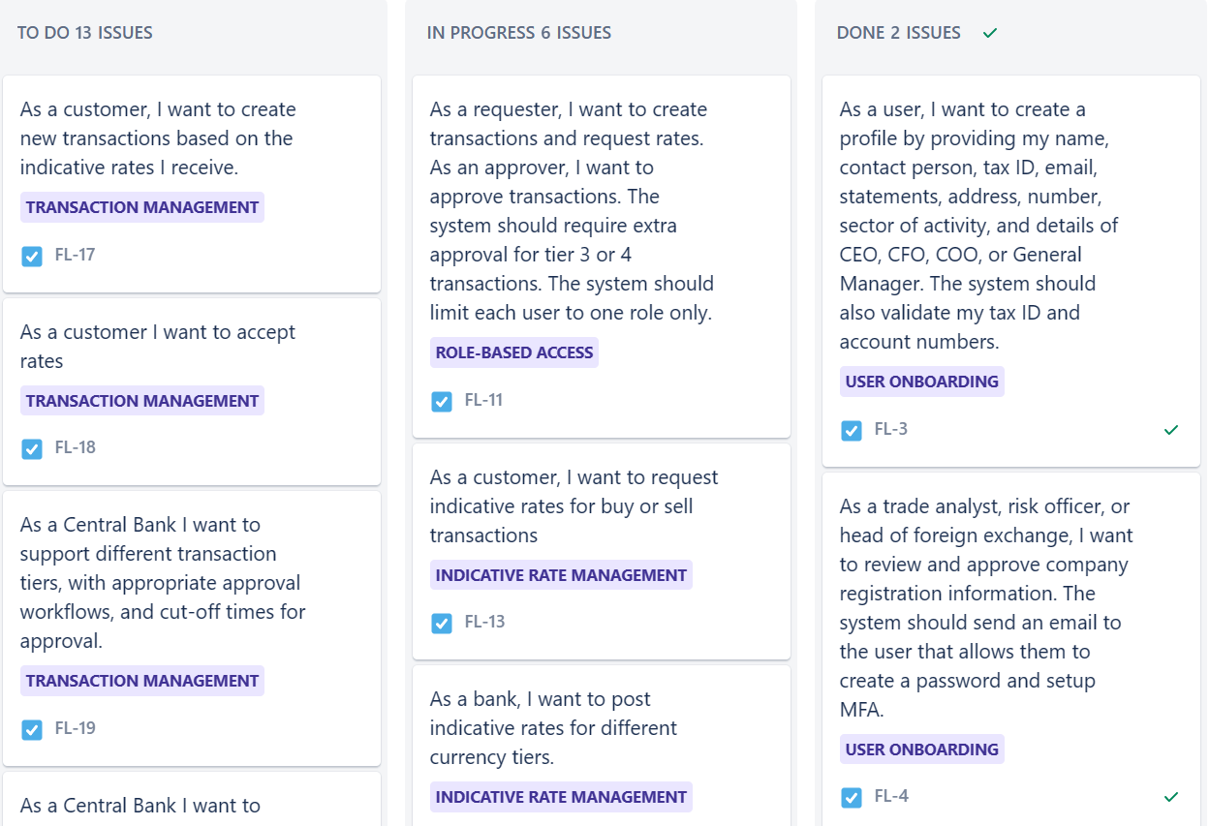

Activity Diagrams

Activity diagram (Onboarding):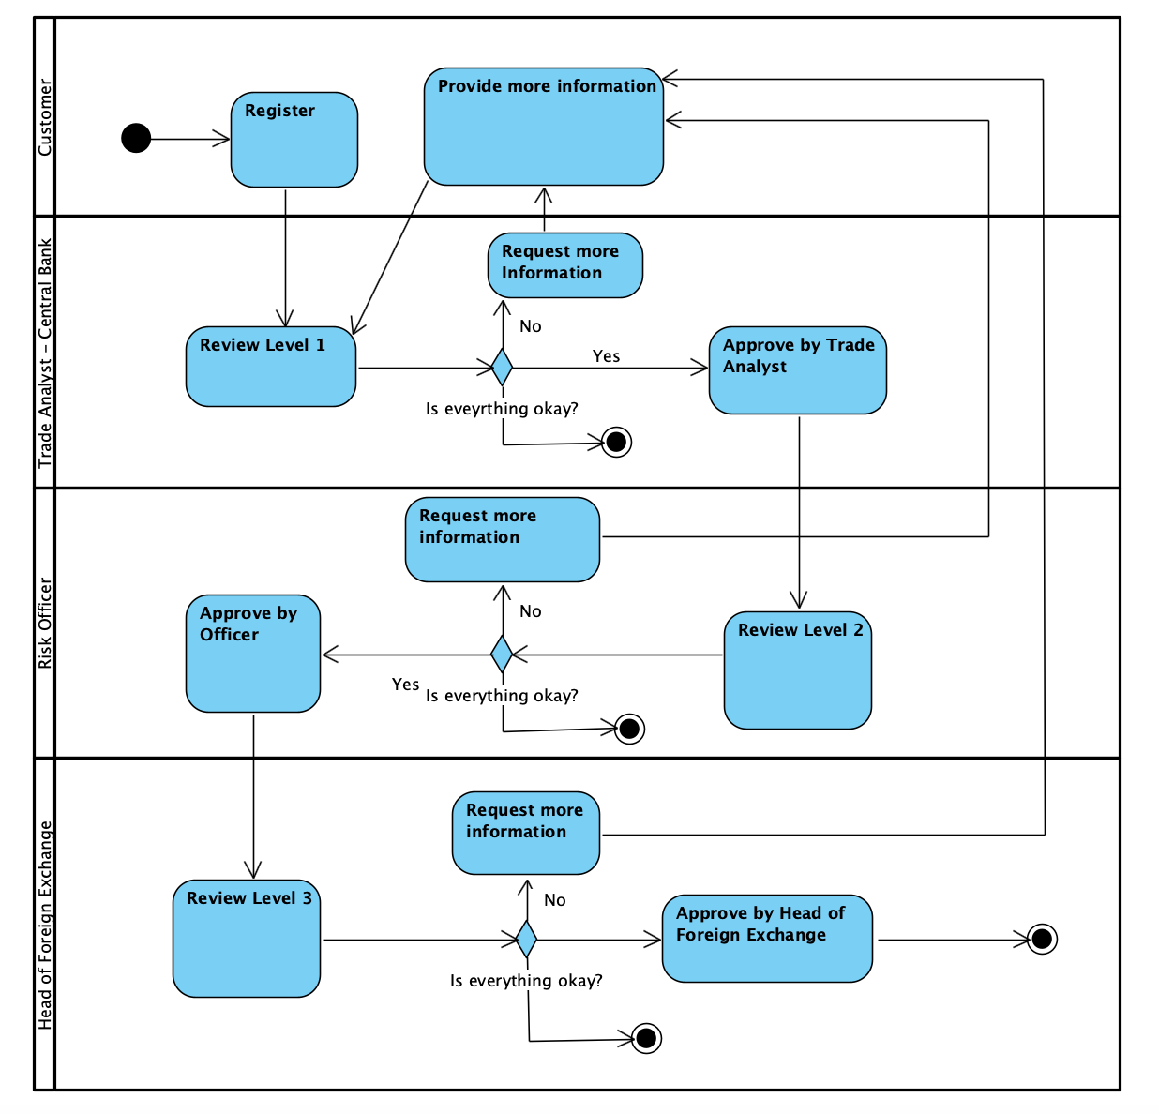

Activity Diagram (Transaction):

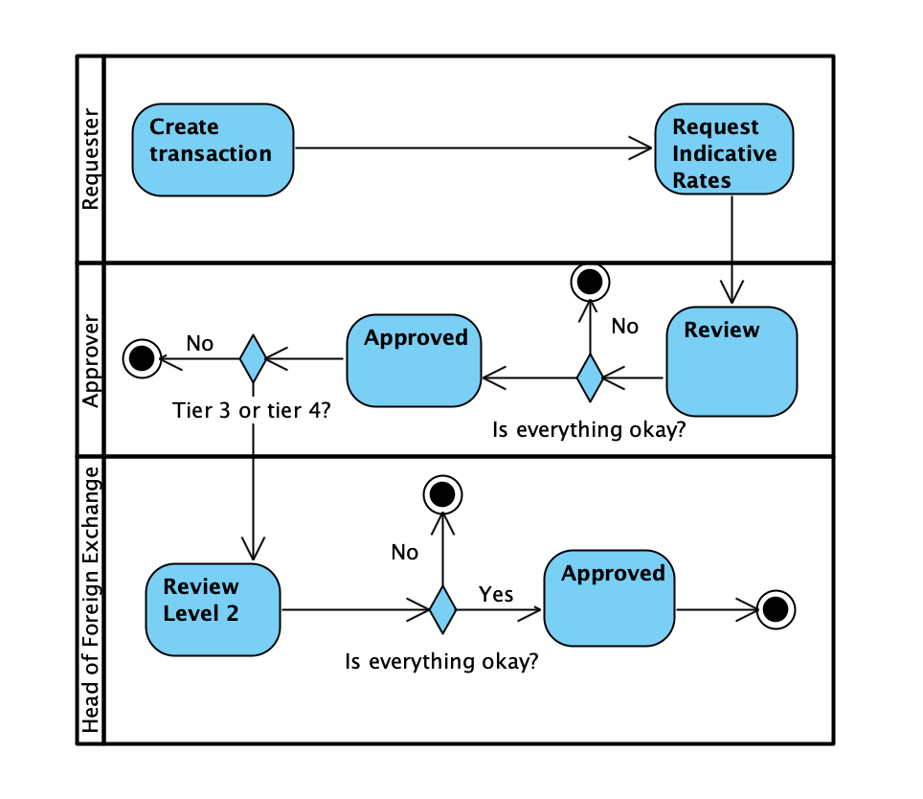

Sequence Diagrams

Sequence Diagram (Onboarding):

Sequence Diagram (Transaction):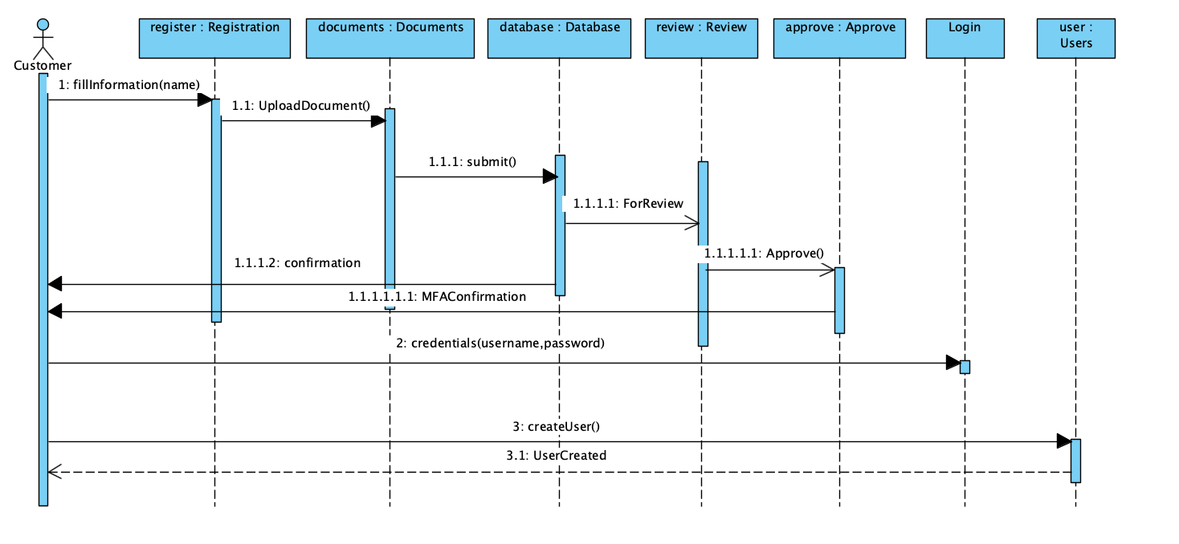

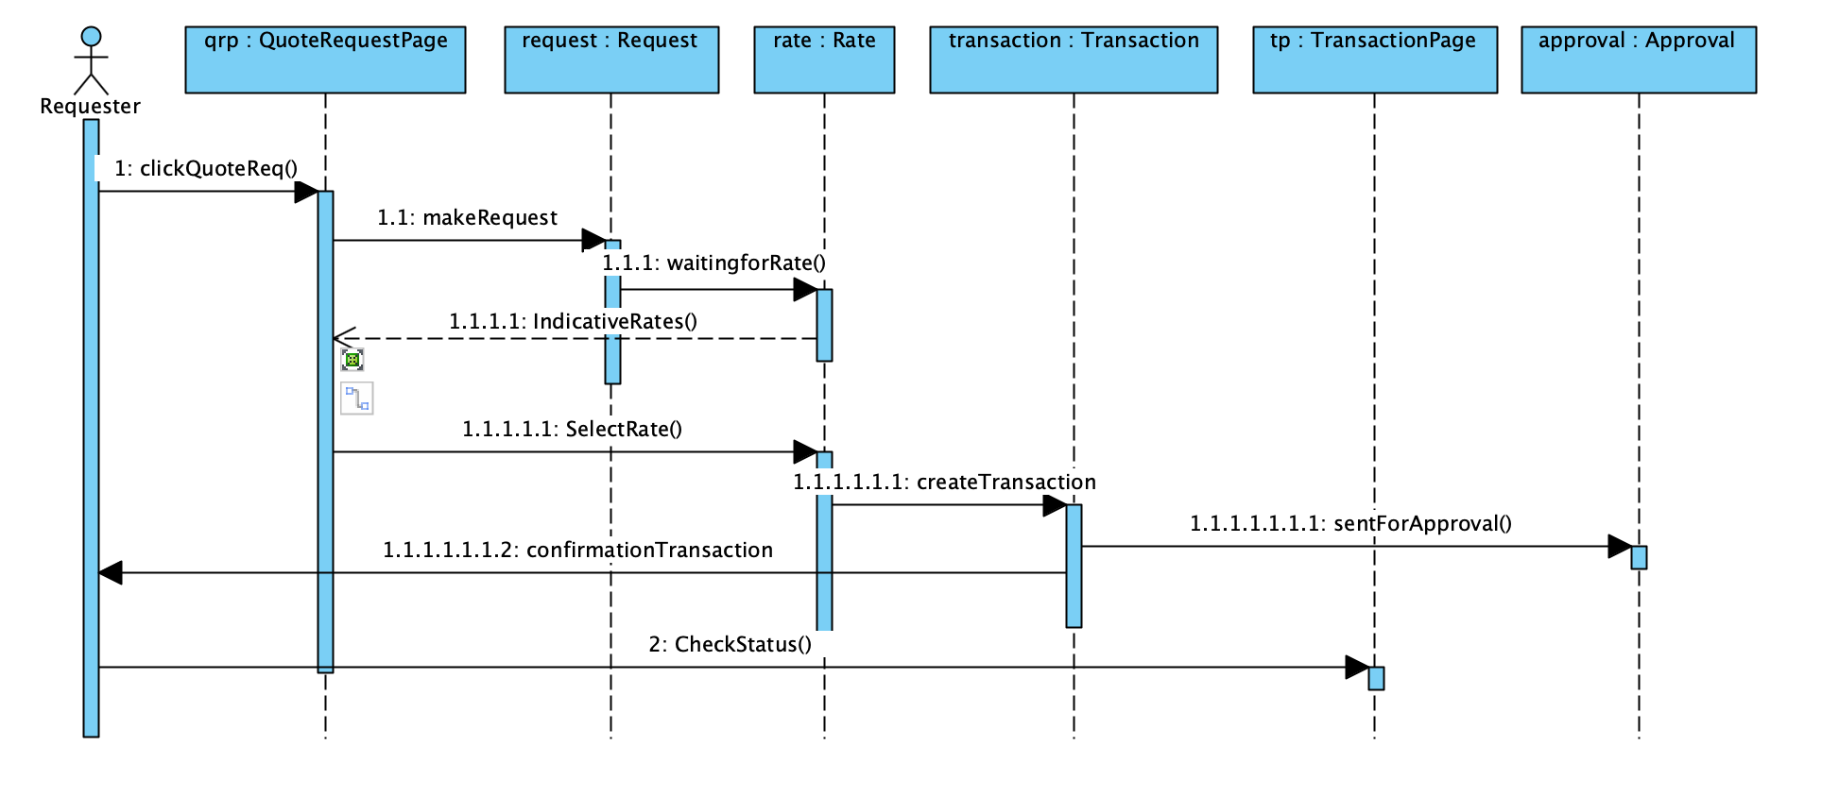

Deployment Diagram

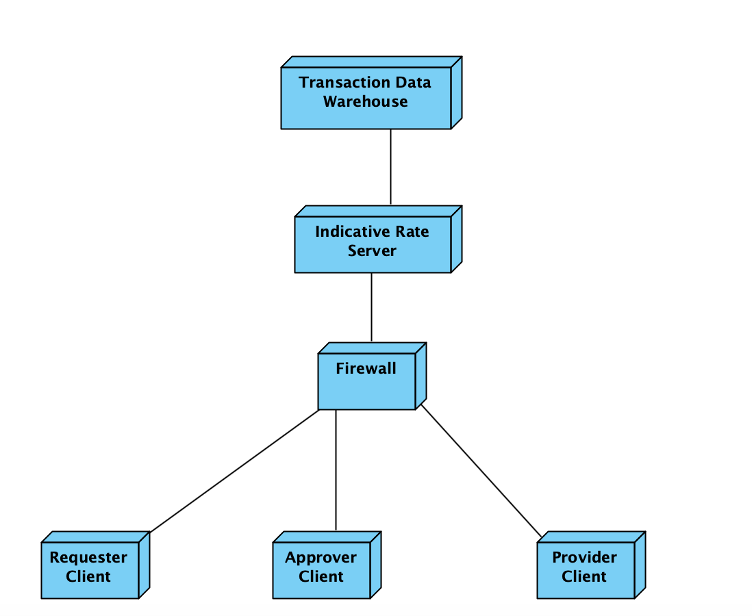

User Interface

https://www.figma.com/file/82K9zMYmIyLRYVHWzpGVTD/FX-LINK?type=design&node-id=2%3A36&t=zop6Vlg7Qv9SkQ5W-1

5. Lessons Learned will also serve as a conclusion for your report.

a. In terms of project management

From creating this CRM system, the team learned the following lessons:

Understanding customers’ needs and their interactions with the software is crucial in the further development of the application.

1. Strengthening data management systems so that it contains the right data sets. Data protocols and data filtering procedures and security measures should be maintained as well.
2. User Interface and User Experience should be easy for different age demographics. This can make it easy for the customer service, sales, and management departments to interact with the customers.
3. This system will have to be updated so that it can integrate other necessary software applications. Marketing and sales automation and analytics should be able to also integrate into the system.
4. The application should be able to support the scalability of the business at all times. Large data files, users, and interaction requests should be supported by the CRM.
5. The system should be changeable and customizable in case it requires or does not require a field. The application should let a feature in and out according to the needs of the company and customers as well.
6. Improvement and updates should be made regularly to keep up with security issues and bugs. To support the constantly updating nature of a kanban board, the CRM should be able to effectively work all the time and this will require constant maintenance as well.

b. In the class itself

1. Collaboration with the team was hard because of different schedules and priorities. The project required each person to play different roles and assign tasks, which made the workflow get easier towards the end.
2. Design and decision-making kept changing because of the market that is competing alongside them. This made the team change many things even if it was last minute.
3. Meeting the timelines because of the last-minute changes was hard and preparing to present the product was done right during the last minute after knowing what are the right requirements.

c. What was the most challenging part of the projects

1. Complexity of the Customer Relationship Management systems because most of the time one or few critical elements are left out during the planning phase.
2. Data management requires organization and constant maintenance, therefore it is important to perform them at the right time. Finding the right timeline to implement them is as important as executing the plan on time.
3. Configuring the right features into the plan so that there are no unnecessary expenses on the budget was a challenging task because each department will have demands and requests that will have to be prioritized among all the ones that were planned to be on the application.
4. Reporting the data correctly and accurately for the development of the application will require its own individual team and to make use of this analysis it needs to study for further improvements.

d. Future works

1. Prepare for a change of management when the time comes for the company to have a new ownership. This will require changes in communications and marketing systems and much more.
2. Provide training for employees so that their onboarding and time during employment will be an easy transition. Inform employees and customers about regular updates to show transparency.
3. Keeping up with analyzing the data in a proper manner to create a good relationship and create marketing strategies. Start marketing the product to foreign countries for a bigger customer base.
4. Making the application more than just a foreign exchange platform to enable trading, a real-time value tracker, and a money exchange medium.